Task: Cloud Watch and Cloud Trail

Task 1: Enable CloudTrail Monitoring and Store Events in S3 and CloudWatch Logs
Purpose
CloudTrail records every API call made in your AWS account. It helps with:
- Security auditing
- Compliance
- Troubleshooting
- Tracking who performed which action
CloudTrail stores logs in:
- Amazon S3 (long-term storage)
- CloudWatch Logs (real-time monitoring)

Step 1: Create an S3 Bucket
Purpose
Store CloudTrail log files permanently.
Command
aws s3 mb s3://sarfaraz-cloudtrail-logs-12345 --region us-east-1
Command Purpose
Command | Purpose
aws s3 mb | Creates a new S3 bucket
--region | Creates bucket in specified AWS Region
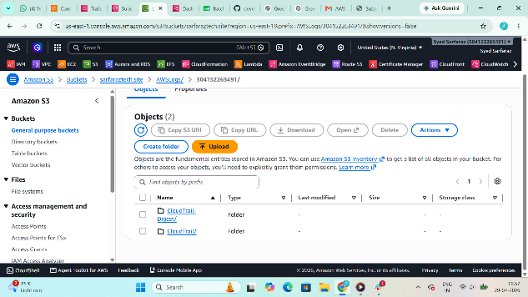

Step 2: Create a CloudWatch Log Group
Purpose
CloudTrail sends events to CloudWatch Logs for monitoring.
Command
aws logs create-log-group \
--log-group-name CloudTrailLogs
Command Purpose
Command | Purpose
aws logs create-log-group | Creates CloudWatch Log Group
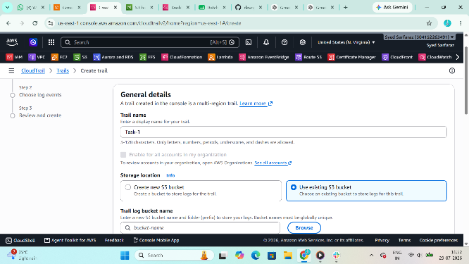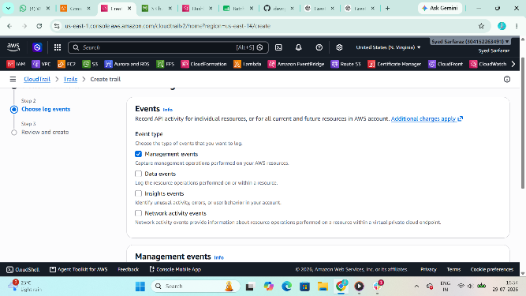
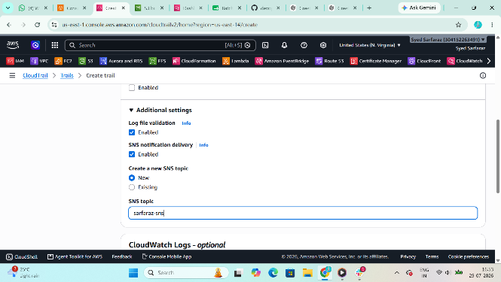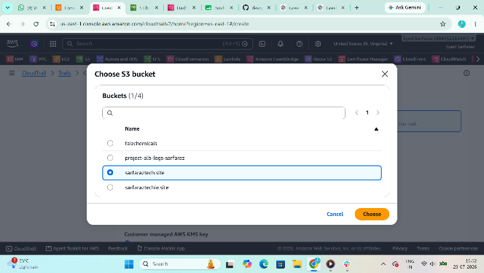
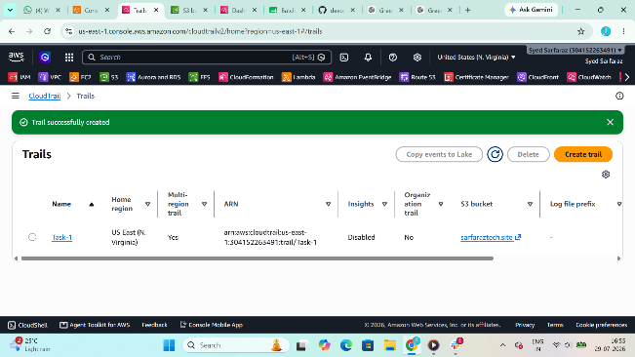

Step 3: Create IAM Role for CloudTrail
Purpose
Allows CloudTrail to write logs into CloudWatch.
Trust Policy
{
"Version":"2012-10-17",
"Statement":[
{
"Effect":"Allow",
"Principal":{
"Service":"cloudtrail.amazonaws.com"
},
"Action":"sts:AssumeRole"
}
]
}
Save as
trust-policy.json
Create Role
aws iam create-role \
--role-name CloudTrail_CloudWatchLogs_Role \
--assume-role-policy-document file://trust-policy.json

Attach Policy
aws iam attach-role-policy \
--role-name CloudTrail_CloudWatchLogs_Role \
--policy-arn arn:aws:iam::aws:policy/CloudWatchLogsFullAccess

Step 4: Create CloudTrail
Purpose
Starts recording AWS API activities.
aws cloudtrail create-trail \
--name MyTrail \
--s3-bucket-name sarfaraz-cloudtrail-logs-12345 \
--is-multi-region-trail

Step 5: Enable CloudWatch Logs
aws cloudtrail update-trail \
--name MyTrail \
--cloud-watch-logs-log-group-arn arn:aws:logs:us-east-1:ACCOUNT-ID:log-group:CloudTrailLogs \
--cloud-watch-logs-role-arn arn:aws:iam::ACCOUNT-ID:role/CloudTrail_CloudWatchLogs_Role
Replace
ACCOUNT-ID
with your AWS Account ID.

Step 6: Start Logging
aws cloudtrail start-logging \
--name MyTrail
Purpose
Starts CloudTrail recording.

Task 2: Enable SNS Email Notification
Purpose
SNS sends email notifications whenever CloudWatch Alarm is triggered.
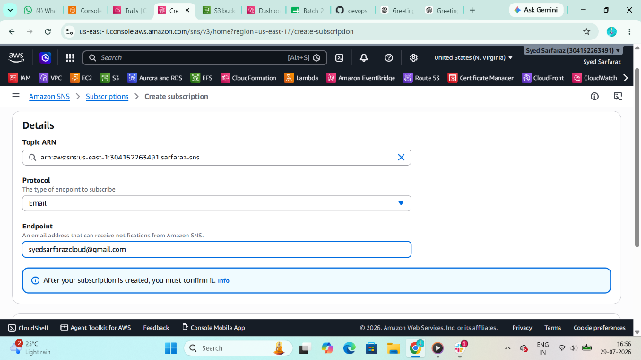

Step 1: Create SNS Topic
aws sns create-topic \
--name CloudTrailAlerts
Output
TopicArn
Save it.

Step 2: Subscribe Email
aws sns subscribe \
--topic-arn TopicArn \
--protocol email \
--notification-endpoint yourmail@gmail.com
Example
aws sns subscribe \
--topic-arn arn:aws:sns:us-east-1:111111111111:CloudTrailAlerts \
--protocol email \
--notification-endpoint syedsarfarazcloud@gmail.com
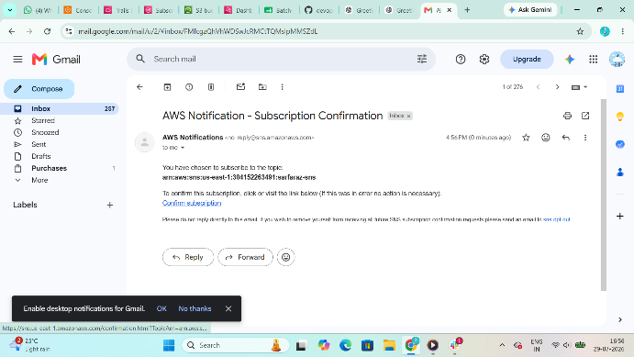

Step 3
Open your Email
Click
Confirm Subscription
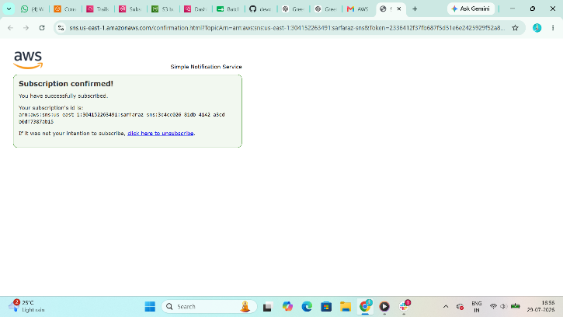

Task 3: Monitor EC2 CPU Utilization
Purpose
CloudWatch collects EC2 metrics such as:
- CPU Utilization
- Disk
- Network
- Status Check

Step 1
Open
CloudWatch
↓
Metrics
↓
EC2
↓
Per Instance Metrics
You'll see
CPUUtilization
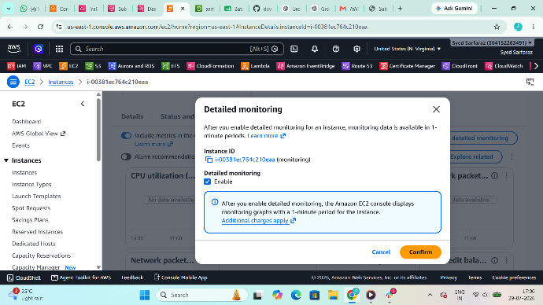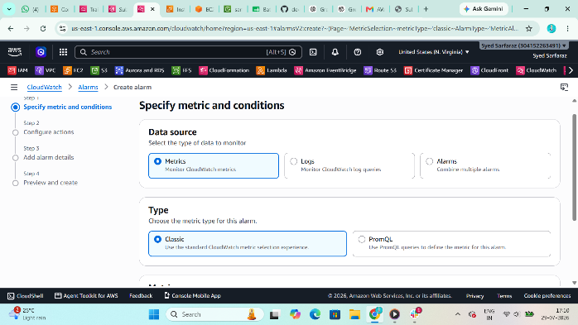
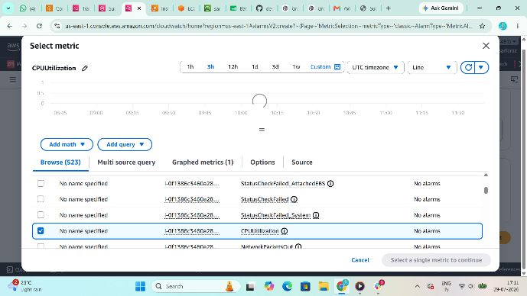

Generate CPU Load
Install Stress
Amazon Linux 2023
sudo dnf install stress -y
Amazon Linux 2
sudo yum install stress -y
Run
stress --cpu 4 --timeout 600
Purpose
Generates CPU load for 10 minutes.
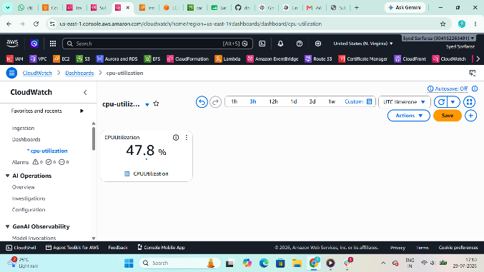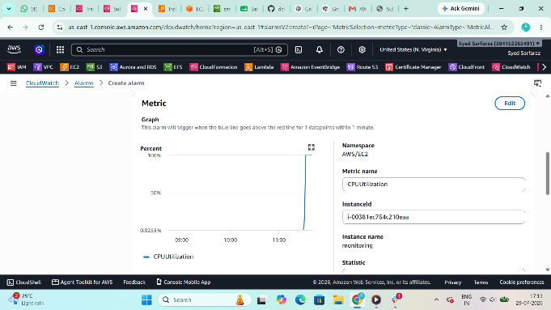

Task 4: Create CPU Alarm (>70%)
Purpose
Automatically sends email if CPU usage exceeds 70%.

Command
aws cloudwatch put-metric-alarm \
--alarm-name HighCPUAlarm \
--metric-name CPUUtilization \
--namespace AWS/EC2 \
--statistic Average \
--period 300 \
--threshold 70 \
--comparison-operator GreaterThanThreshold \
--evaluation-periods 1 \
--dimensions Name=InstanceId,Value=i-xxxxxxxx \
--alarm-actions arn:aws:sns:us-east-1:111111111111:CloudTrailAlerts \
--unit Percent
Replace
i-xxxxxxxx
with your EC2 Instance ID.

Purpose
If CPU exceeds
70%
CloudWatch
↓
Triggers Alarm
↓
SNS
↓
Email
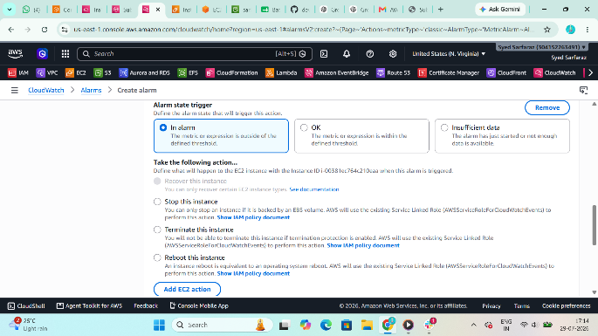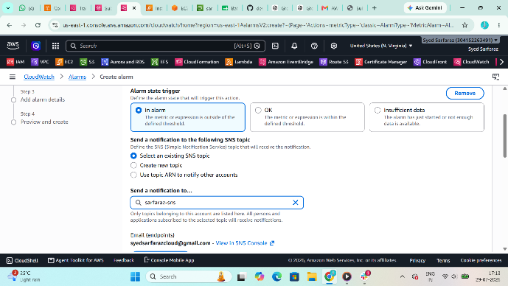
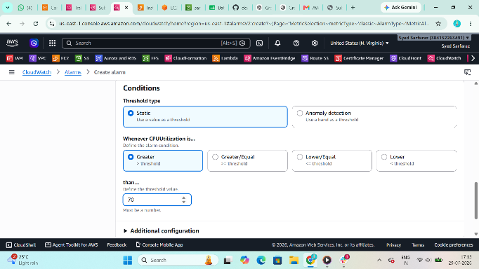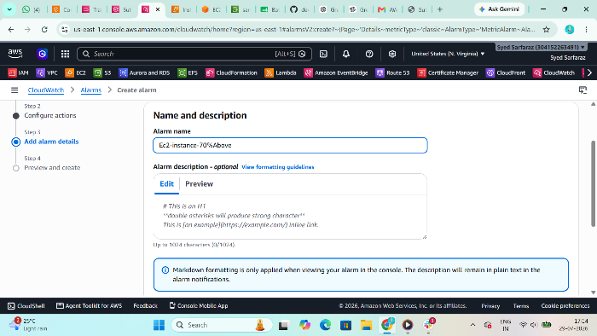
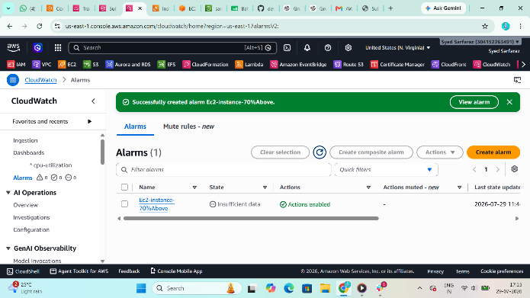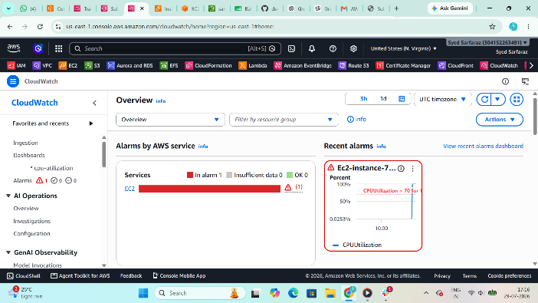
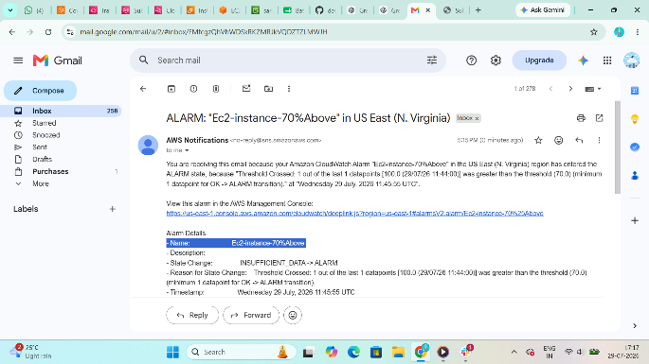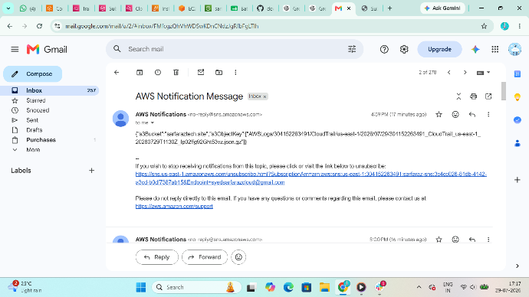

Task 5: Monitor Tomcat Service
Purpose
CloudWatch Agent can collect service status and custom metrics, but monitoring whether a Linux service (such as Tomcat) is running requires a custom metric because CloudWatch does not natively report systemctl service state.

Step 1: Verify Tomcat
sudo systemctl status tomcat
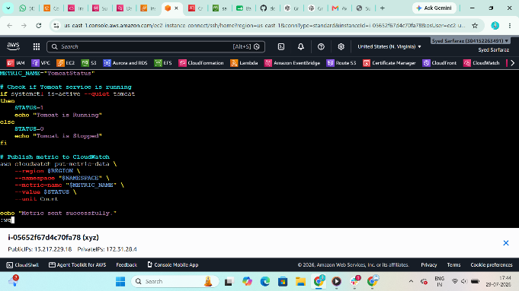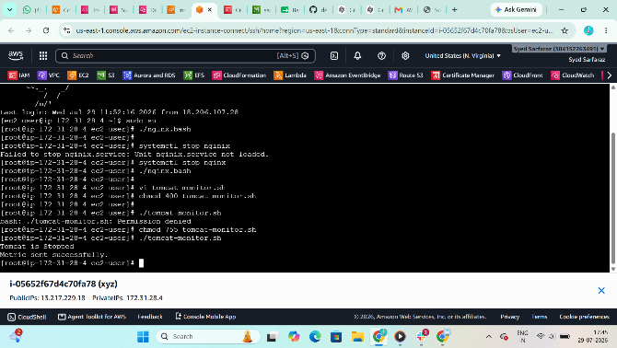

Step 2: Publish Custom Metric
If Tomcat is active:
aws cloudwatch put-metric-data \
--namespace CustomServices \
--metric-name TomcatStatus \
--value 1
If stopped:
aws cloudwatch put-metric-data \
--namespace CustomServices \
--metric-name TomcatStatus \
--value 0
Command Purpose
Value | Meaning
1 | Running
0 | Stopped
You can automate this with a cron job that checks systemctl is-active tomcat every minute and publishes the corresponding metric.
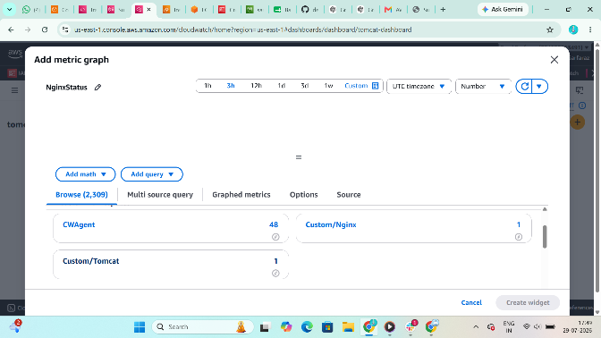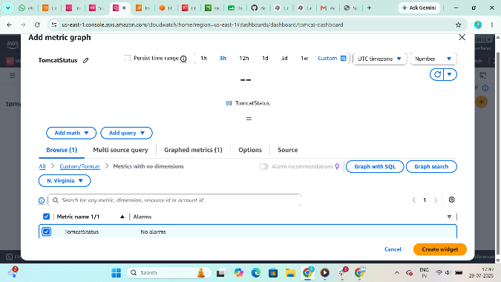

Step 3: Create Alarm
aws cloudwatch put-metric-alarm \
--alarm-name TomcatDown \
--namespace CustomServices \
--metric-name TomcatStatus \
--statistic Average \
--period 60 \
--evaluation-periods 1 \
--threshold 1 \
--comparison-operator LessThanThreshold \
--alarm-actions arn:aws:sns:us-east-1:111111111111:CloudTrailAlerts
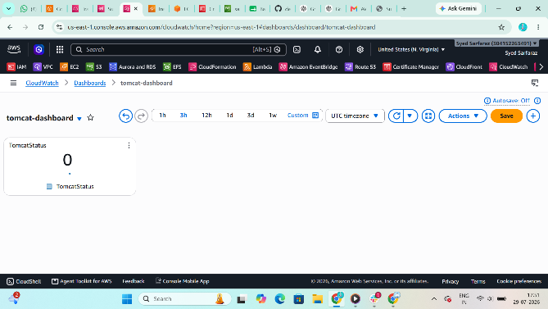

Task 6: Monitor Nginx Service
Purpose
Alert if Nginx is not running by using another custom metric.

Step 1: Verify Nginx
sudo systemctl status nginx
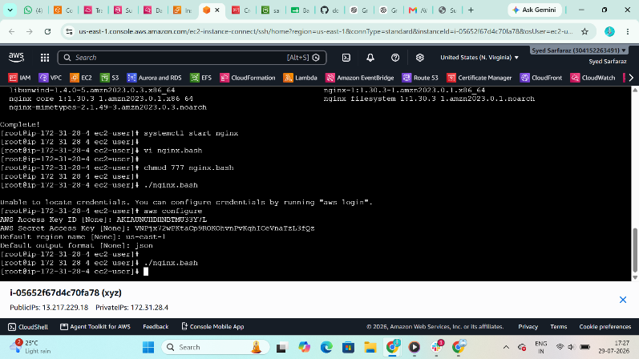

Step 2: Publish Custom Metric
If running:
aws cloudwatch put-metric-data \
--namespace CustomServices \
--metric-name NginxStatus \
--value 1
If stopped:
aws cloudwatch put-metric-data \
--namespace CustomServices \
--metric-name NginxStatus \
--value 0
Again, automate this with a cron job that checks systemctl is-active nginx and publishes the metric every minute.
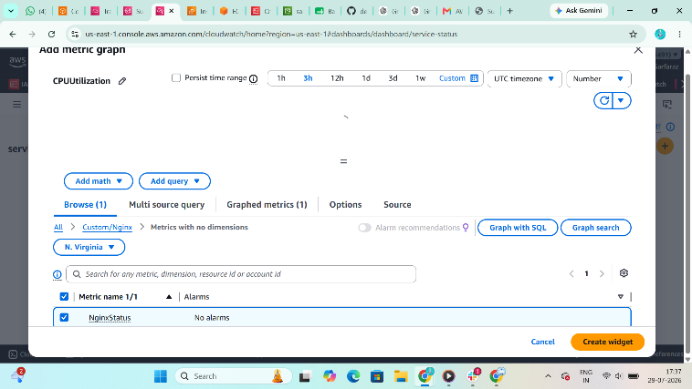

Step 3: Create Alarm
aws cloudwatch put-metric-alarm \
--alarm-name NginxDown \
--namespace CustomServices \
--metric-name NginxStatus \
--statistic Average \
--period 60 \
--evaluation-periods 1 \
--threshold 1 \
--comparison-operator LessThanThreshold \
--alarm-actions arn:aws:sns:us-east-1:111111111111:CloudTrailAlerts
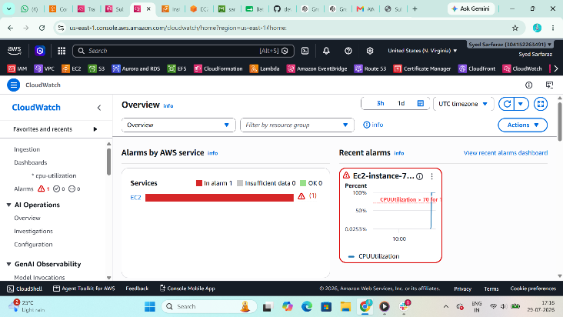

Task 7: Create a CloudWatch Dashboard
Purpose
A CloudWatch Dashboard provides a single view to monitor:
- EC2 CPU Utilization
- Network metrics
- CloudTrail log activity
- Tomcat status (custom metric)
- Nginx status (custom metric)
- CloudWatch alarms
From the AWS Management Console:
- Open CloudWatch.
- Select Dashboards.
- Choose Create dashboard.
- Enter a dashboard name (for example, MonitoringDashboard).
- Add widgets for:
  - EC2 CPUUtilization
  - TomcatStatus (namespace CustomServices)
  - NginxStatus (namespace CustomServices)
  - CloudWatch Alarms
- Save the dashboard.
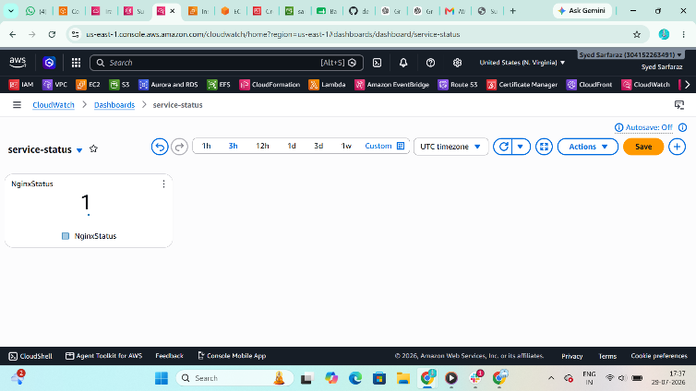
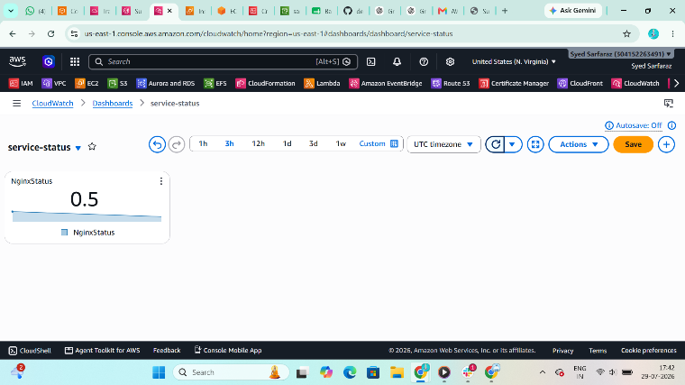

Final Architecture
AWS CloudTrail
│
│
┌───────────┴────────────┐
│ │
▼ ▼
Amazon S3 CloudWatch Logs
│
▼
CloudWatch
Metrics & Alarms
│
┌─────────────────┼─────────────────┐
▼ ▼ ▼
EC2 CPU Alarm Tomcat Alarm Nginx Alarm
│ │ │
└─────────────────┼─────────────────┘
▼
Amazon SNS
│
▼
Email Notification
This workflow ensures CloudTrail events are archived in S3, monitored through CloudWatch Logs, EC2 CPU usage is tracked, service health for Tomcat and Nginx is monitored using custom metrics, alarms are generated when thresholds are crossed, and notifications are delivered by email through SNS.

